**1.1 Background of the Study:**

The background of the Lorbek car online system project is about solving problems with the current system. There was a problem with different kinds of functional and non-functional aspects of this system. The major problem of this old system is that it was based on the offline mode for transactions. There is no such a kind of online payment, management of the payment system. The manual way of processing data, handling data, keeping track of the inventory, and making reports are working effectively.

To solve these issues, the project aims to use automated software to make things run smoother, reduce mistakes, and improve how the showroom is organized. The decision to do this comes from realizing that operations are getting more complicated, and the old manual ways cannot keep up with the changes.

This project is creating a custom solution for the Lorbek Car online system to meet their specific needs and make it easier for everyone to use. The main aim is to use automation to make data more accurate, processes smoothly, and to achieve the overall experience for customers. The project highlights the benefits of the new online system, like making operations more efficient, processes simpler, improving customer service, and helping with better decision making.

This project is not just about using new technology. It is a crucial move to help the showroom grow and be successful in the long run. It considers challenges and opportunities in the car industry, aiming to make the showroom strong and able to adapt to changes in the market. By learning from successful projects in the car business and listening to the views of key people like managers, employees and customers, the project wants to create a complete solution that works for everyone involved. In simple words the background study of the Lorbek car showroom needs a new and advanced online system highlights why the Lorbek car showroom needs a new and advanced online system. What are the problems with the previous manual offline system and how this project aims to solve by using different new technology and solutions.

### 3.1 Functional Requirements:

Admin

|  |  |  |
| --- | --- | --- |
| **FR.NO** | **Functional Requirements** | **Comments** |
| FR1 | Admin Login | An Administrator should be able to log into their account using their username and password |
| FR2 | View Dashboard | The admin should be able to view dashboard with information about users, new users, total reservations, and revenue. |
| FR3 | Create Scheduling Tasks | The admin should be able to schedule tasks, run appointments, approve purchase orders. |
| FR4 | View Vehicle Inventory | The admin should be able to manage the inventory of cars, able to add or delete the vehicles. |
| FR5 | View Available Vehicles | The admin should be able to see the list of available vehicles. |
| FR6 | View Stock Levels | The admin should be able to view the stock level of the vehicle. |
| FR7 | Generate Notification Alert | The admin will be notified about stocks when the stock falls below the minimum level. |
| FR8 | Manage order | The admin should be able to manage orders, view the order details, updating processing, shipped, delivered, and cancel if necessary. |
| FR9 | View Bookings | The admin should be able to view all the booking made by users including user information, car details, cost, and payment type. |
| FR10 | Manage users | The admin should be able to manage all signed users with their personal details such as name, address, email, and contact number. |
| FR11 | Manage Accessories | The admin able to update available parts, accessories, availability, and low stock details. |
| FR12 | Manage Shipping | The admin should be able to send notification about shipping information to the users with product details, processing time, delivery date with tracking code. |
| FR13 | Maintain Records | The admin should be able to identify and store record following company policies, standards, and guidelines. |
| FR14 | Manage Payment | The admin should be able sign into the payments profile, user record, user access permission type. |
| FR15 | Create Vendor Invoice | The admin should be able to make a vendor invoice, make PO from purchase request, and add import cost on vehicles. |
| FR16 | Manage Refund Request | The admin should be able to approve a refund request and create a return invoice with refund receipt for multiple vehicles. |

Users

|  |  |  |
| --- | --- | --- |
| **FR NO.** | **Functional Requirements** | **Comments** |
| FR17 | User registration | Allows to users to sign up to the system and create their profile. |
| FR18 | User Login | Allows users to login to their account using registered email and passwords. |
| FR19 | Car search Option | Allows users to search for cars based on various criteria, such as make, model, price range, and features. |
| FR20 | View Car Categories | Allows users to view the categories of the vehicle by brands, models, accessories parts. |
| FR21 | Choose Filter Options | Allows users to select a filter option like choosing vehicle brands, color, models, in the categories |
| FR22 | View Vehicle Information | Allows users to view the details like country of origins, location, showroom, brand, models of the selected cars. |
| FR23 | Watch Videos | Users will be able to watch a video on the website about the cars. |
| FR24 | Make a Purchase | Allows users to make a purchase a vehicle based on custom sales price per model, interior color, added accessories and added extra charges by vehicle code. |
| FR25 | Create Loan Application | Enables users to apply for a loan to finance their car purchase, providing necessary financial details. |
| FR26 | Create a Booking | Allows users to schedule test drives or book a specific car for purchase, providing flexibility in the buying process. |
| FR27 | Create Customer profile | Let’s users manage their personal information, preferences, and track their interaction history with the showroom. |
| FR28 | Create a payment | Facilitates the processing of payments for car purchases, loans, or other financial transactions. Also, Users will be able to choose a payment option like bank or credit card. |
| FR29 | View Shopping Cart | Allows users to view the shopping cart based on their selected items and be able to proceed to checkout. |
| FR30 | Create Feedbacks and Reviews | Allows users to provide feedback on their experience, rate purchased cars, and leave reviews for the benefit of other users. |
| FR31 | View Notifications Alert | Sends users alerts and notifications regarding their bookings, payments, or any relevant updates. |
| FR32 | Add to Wishlist | Enables users to create and manage a wish list of cars they are interested in but have not yet purchased. |
| FR33 | Create History and Records | Displays the user's purchase history, including details of past transactions, test drives, and interactions with the showroom. |
| FR34 | Use Price Calculator | Allows users to calculate sales price for selected vehicles with discount percentage. |
| FR35 | Make Pre-order/Reserve Request | Allows user to pre-order or reserve the vehicle. |
| FR36 | Create Order Inquiry | Allows users to create an inquiry with the customer service. |
| FR37 | Create a Refund Request | Allows users to able to make a refund request. |
| FR38 | Use AI API Chatbot | Allows users to access the AI chatbot. When asked a question, the chatbot will answer using the knowledge database that is currently available to it. |

**6. Context Diagram/Diagram Level 0:**

**7.2.1 DFD level 2**

**Payment management DFD level 2**

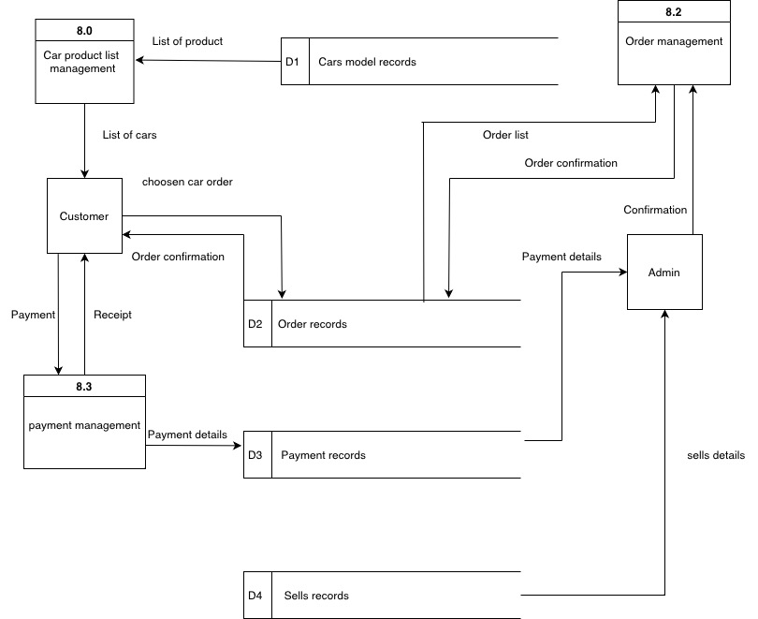

**8. Sequence Diagram**

